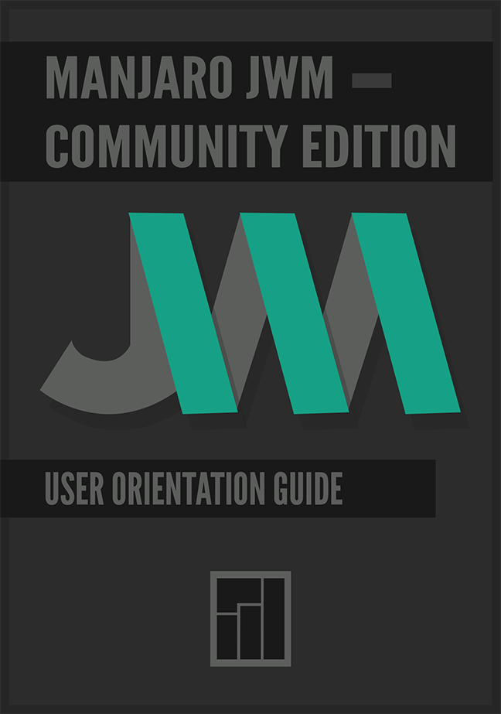

Contents

1. Overview 1
1.1. License 1
2. General Observations 1
3. Notitications and Update 2
3.1. Assist Notitications and Update with Update-Notifier 2
4. Install Packages that Give Acess to AUR 2
5. Careful Using: Configuration Tool for JWM and Pacli Package Manager 2
6. Shortcuts 3
6.1. Application Shortcuts 3
6.2. Screen Lock Shortcut 3
6.3. Reconfigure (Restart) JWM Shortcuts 3
6.4. Pacli Package Manager Shortcut 3
6.5. JWMConf Configuration Tool Shortcut 3
6.6. Audio Shortcuts 3

6.7. Screenshot Shortcut 4
6.8. Windows Shortcuts 4
6.8.1. Tiling 4
6.8.2. Changing the Virtual Desktop 4
6.8.3. Sending the Focused Window to a Certain Virtual Desktop 5
7. Key Applications Installed by Default in Manjaro JWM Community Edition 5
8. Script All: Scripts to Install Additional Features 7
9. How to Make a Bootable Live USB 7
10. Menus in JWM 8

11. How to Reconfigure JWM and Load Changes 8

12. How to Enable and Disabled Services 9

12.1. Activate NetworkManager (nm-applet) in the Current Sessions 9

13. Changing the Weather (City and Temperature) in Conky 9

14. Changing the Information of the Battery in Conky 10

15. How to Edit Pacli and JWMConf 10

16. Dunst Adjust with Your Screen 10

17. Remove Popoup Welcome 11

18. Changing the Windows Buttons JWM 11

19. How to Exit and Lock the Screen 12

20. Importants Sites 12

21. Support 13

